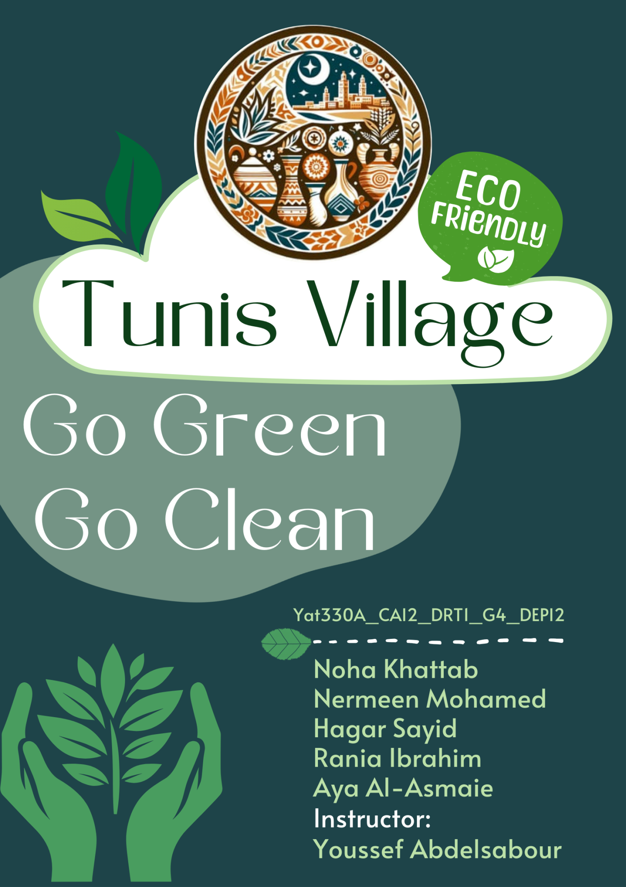

**Tunis Village**

**Titles**

**Content**

**Scope - About Us and the Project**

At the heart of what we do is a deep love for Tunis Village and its vibrant culture.

**Our mission** is to share the beauty of this hidden gem in Fayoum with the world, while promoting sustainable tourism that respects the environment and supports local communities.

Tunis Village is not just a place—it's a story of craftsmanship, nature, and tradition. From the artistry of its pottery workshops to the peaceful embrace of its eco-lodges, we believe in providing experiences that allow visitors to reconnect with nature and culture in an authentic, responsible way.

**Our goal** is to help travelers discover the true essence of Tunis Village, offering them an opportunity to support eco-tourism initiatives that protect the land, celebrate local craftsmanship, and promote cultural preservation. Through this project, we aim to encourage sustainable practices, highlight the importance of eco-friendly travel, and create meaningful connections between visitors and the local community.

**Join us** on a journey to explore Tunis Village responsibly, and be part of the movement towards a more sustainable future for tourism in Egypt.

**Team Roles**

**Research & Analysis (Before & After)**

Nermen Mohamed and Noha Khattab

**Setting Strategy (Overall Project Strategy)**

Hager Sayid and Nermen Mohamed

**Content Creation & Media (Writing, Visuals, Social Media Posts)**

Aya Al Asmaie and Rania Ibrahim

**Media Buyer (Social Media Ads, Paid Campaigns)**

Noha Khattab and Hager Sayid

**Contents**

**PART 1– RESEARCH PHASE 4**

**What is Eco-Tourism? 4**

**How Does Tunis Village Apply Eco-Tourism Principles?  7**

**Research on Tunis Village 8**

**Unique Selling Points (USPs) 9**

**Identifying the Target Audience 10**

**SWOT Analysis of Tunis Village as an Eco-Tourism Destination 12**

**Competitors 13**

**Buyer Personas 16**

**OUR BUSINESS MODEL 20**

**PART 2– Key Performance Indicators (KPIs) 21**

**PART 3– Setting the Strategy 25**

# **PART 1– RESEARCH PHASE**

**(by: Nermen Mohamed and Noha Khattab)**

## **What is Eco-Tourism?**

* Responsible travel to natural and cultural sites, ensuring minimal environmental impact.
* Supports local communities while preserving traditions and heritage.

**Why is it important?**

Tourism helps in development, creating employment opportunities, with positive impact on the economy of a country. However, it also may create negative impacts on the environment, cultural heritage, habitat, and its inhabitants when not properly managed.

**What is the opposite of sustainable tourism?**

1. Littering
2. Clashes of culture
3. Lack of conservation education
4. Contamination of the natural environment

Thus, sustainable tourism should: Make optimal use of environmental resources that constitute a key element in tourism development, maintaining essential ecological processes and helping to conserve natural heritage and biodiversity.

**The below are examples of targets of Sustainable Tourism[1]**

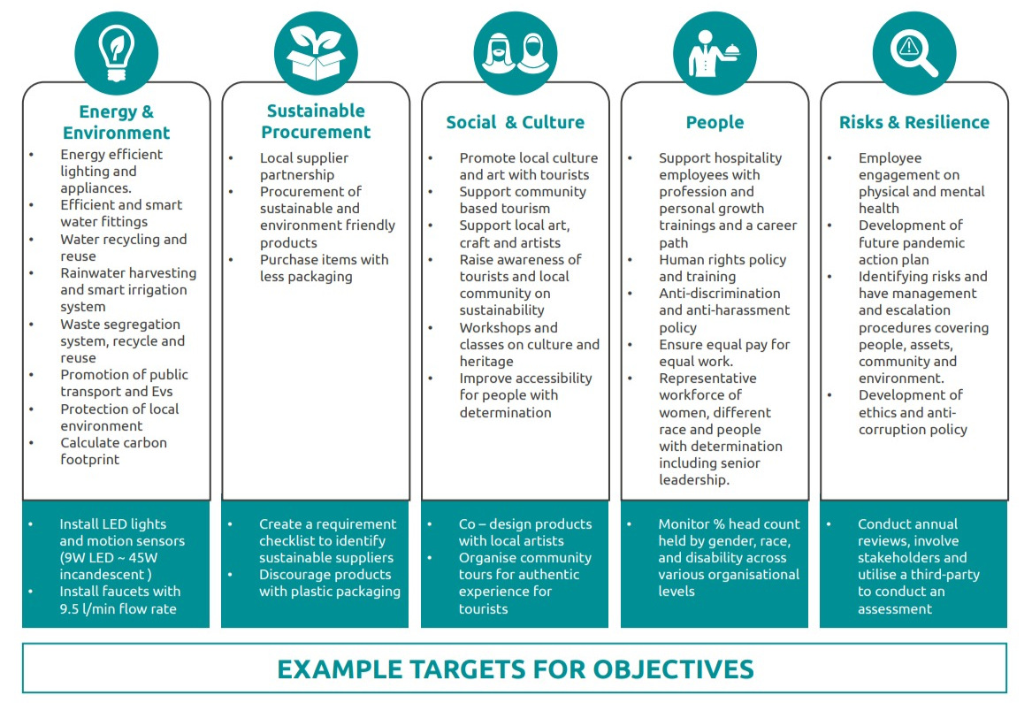

**EFFORTS FOR SUSTAINABLE TOURSIM**

United Nations World Tourism Organization (UNWTO) are providing training to hotels in an effort to upskill the staff on sustainable practices.

Egypt and UAE are bringing sustainability to the forefront as hosts of COP 27 and 28 conference. The private sector is seizing this opportunity to showcase its initiatives and drive.

Many independent agencies to audit and certify the sustainability efforts undertaken by these entities. Number of certifications have emerged in the industry to guide private sector players on their journey to sustainability compliance, such as Green Key, UNWTO, GSTC

The World Travel and Tourism Council (WTTC) provides a framework called WTTC Hotel Sustainability Basics which is a coordinated set of sustainability indicators that all hotels should implement as a minimum to implement the criteria over the next three years

## **How Does Tunis Village Apply Eco-Tourism Principles? [2]**

✅ Sustainable Architecture – Homes, hotels, and ecolodges use mudbrick & natural materials to reduce carbon footprints.   
✅ Eco-Friendly Practices – Solar energy, waste recycling, and locally sourced materials.   
✅ Community-Led Tourism – Local artisans, guides, and entrepreneurs manage tourism activities, ensuring direct economic benefits.   
✅ Nature Conservation – Protects Lake Qarun’s birdlife, promotes low-impact tourism activities like birdwatching & hiking.

**3️. Why is Sustainability Important for Tunis Village?**

* Preserves cultural identity (pottery traditions, local craftsmanship).
* Supports economic growth while maintaining low environmental impact.
* Attracts conscious travelers looking for authentic experiences.

## **Research on Tunis Village**

* History & Culture: Originally a small agricultural village in Fayoum, Tunis became a hub for art and eco-tourism thanks to Evelyne Porret, a Swiss potter introduced to the village by her husband, Egyptian poet Sayed Hegab.
* Eco-Tourism Attractions:
* Pottery craftsmanship – Home to the renowned Tunis Pottery School.
* Natural beauty – Overlooks Lake Qarun, a hotspot for birdwatching.
* Outdoor activities – Horse & camel riding, boat trips, desert trekking.
* Annual Pottery Festival – Celebrates traditional crafts & attracts global visitors.
* Current Tourism Practices:
* Focuses on sustainable tourism – eco-lodges, locally run hotels, and traditional mudbrick architecture.
* Artisans sell pottery locally and internationally, ensuring economic growth.

In Summary:

* Tunis Village has undergone an extraordinary transformation, from a marginalized rural area to a thriving eco-tourism destination. The village’s success is built on local talent, sustainable practices, and the vision of Evelyne Porret.
* Today, Tunis Village is a model for heritage-based economic development, with:

✅ Zero idleness – Everyone in the community plays a role in the economy.   
✅ A thriving tourism sector – Pottery, eco-lodges, and adventure activities attract visitors.   
✅ A commitment to sustainability – Eco-friendly housing, local materials, and renewable energy solutions.

### **Unique Selling Points (USPs)**

✅ Pottery Craftsmanship – High-quality, handcrafted pottery with unique environmental designs.   
✅ Eco-Lodges & Sustainable Tourism – Mudbrick houses, solar energy, and locally owned accommodations.   
✅ Natural Landscapes & Outdoor Activities – Lake Qarun, birdwatching, horseback riding, and hiking.   
✅ Cultural Appeal – A peaceful artist retreat with a rich heritage, attracting creatives and eco-tourists**.**

### **Identifying the Target Audience**

**1️. Age Groups**✅ Young Travelers (18-30 years old) – Backpackers, students, and adventure seekers looking for affordable, immersive experiences.   
✅ Middle-Aged Professionals (30-50 years old) – Art enthusiasts, eco-conscious tourists, and working professionals seeking a cultural retreat.   
✅ Retirees (50+ years old) – Nature lovers, slow travelers, and those interested in heritage tourism.

**2️. Interests & Motivations**✔️ Eco-Conscious Travelers – Tourists who prefer sustainable travel and want to support local communities.   
✔️ Cultural Enthusiasts – People fascinated by handicrafts, traditional pottery, and rural lifestyles.   
✔️ Nature Lovers & Adventure Seekers – Birdwatchers, hikers, and photographers drawn to Lake Qarun’s landscapes.   
✔️ Luxury & Wellness Tourists – High-end travelers who prefer eco-lodges & boutique stays away from crowded cities.

**3️. Income Level**💰 Budget Travelers – Students, backpackers, and digital nomads looking for affordable guesthouses & local experiences.   
💰💰 Mid-Range Travelers – Professionals and families willing to spend on comfortable ecolodges, activities, and guided tours.   
💰💰💰 Luxury Tourists – High-income individuals booking exclusive ecolodges, private excursions, and premium services.

**4️. Geographical Location**🌍 Domestic Travelers – Cairo residents & Egyptians seeking a peaceful weekend retreat away from city life.   
🌍 European & North American Tourists – Travelers from France, Switzerland, Germany, and the U.S., interested in culture and eco-tourism.   
🌍 Arab & Gulf Tourists – Visitors from the UAE, Saudi Arabia, and Kuwait, drawn to unique cultural experiences.

### **SWOT Analysis of Tunis Village as an Eco-Tourism Destination**

### **Competitors**

**\* Analyzing Competitor Pages**

More than 20 pages that have Tunis Village as the main focus of their page. However, all of these pages have the objective are made for profit purposes, mainly to organize trips to Tunis Village.

None of these pages discuss Tunis Village from an awareness perspective, or discuss the Sustainable Tourism aspect of Tunis Village.

**\* Analyzing Competitor Destinations**

**1.Fayoum Oasis:**

|  |  |  |
| --- | --- | --- |
| **Strengths** | **Weaknesses** | **Opportunity for Tunis Village** |
| * Natural Beauty: Includes stunning landscapes like Lake Qaroun, Wadi El Rayan waterfalls, and desert views. * Diverse Activities: Hiking, birdwatching, boat rides on the lakes, and desert safaris. * Rich Historical Sites: Ancient Egyptian monuments and fossils. | * Less Cultural Focus: Primarily nature-based activities, with fewer opportunities to connect with local culture or crafts. * Limited Specialized Experiences: Lacks unique hands-on cultural experiences like pottery-making. | * Tunis Village can capitalize on its cultural immersion and pottery workshops. * Eco-lodges and sustainability practices are key differentiators in a region that mostly offers general tourism. |

**2.Wadi El Rayan:**

|  |  |  |
| --- | --- | --- |
| **Strengths** | **Weaknesses** | **Opportunity for Tunis Village** |
| * Protected Nature Reserves: Known for waterfalls, lakes, desert safaris, and birdwatching. * Peaceful Escape: A great place to disconnect with nature and wildlife. | * Limited Cultural Activities: Fewer opportunities to explore local culture or engage in artisanal crafts. * Basic Accommodations: Less developed in terms of luxurious or eco-friendly stays. | * Tunis Village offers a more immersive cultural experience with its pottery schools and workshops. * Sustainable, eco-friendly accommodations can attract eco-tourists seeking more than just nature. |

**3.Lake Qaroun:**

|  |  |  |
| --- | --- | --- |
| **Strengths** | **Weaknesses** | **Opportunity for Tunis Village** |
| * Scenic Beauty: Lake Qaroun offers a beautiful, peaceful setting for boat rides, fishing, and relaxation. * Birdwatching Paradise: A favorite spot for birdwatchers due to its rich variety of species. * Popular for Water Activities: Many visitors come for boating, fishing, and simply enjoying the calm waters. | * Limited Experiences Beyond Nature: Mostly water activities with few cultural or adventure options. * Lack of Eco-Tourism Focus: While beautiful, it lacks eco-tourism principles such as sustainability or conservation. | * Tunis Village can emphasize its eco-tourism focus, offering sustainable lodging, pottery workshops, and a deeper cultural experience beyond just the natural beauty. * Cultural workshops and immersive village life can attract travelers seeking more than just a nature retreat. |

### **Buyer Personas**

**Buyer Persona 1: Egyptian Woman**

* Name: Sara
* Age: 30
* Location: Cairo, Egypt
* Income Level: Mid to high income
* Occupation: Professional teacher
* Interests: Nature, sustainability, wellness, arts & crafts, local culture
* Values: Authentic experiences, sustainable travel, relaxation, family time
* Goals: Escape city life, enjoy nature, experience Egyptian culture, support local communities
* Pain Points: Lack of eco-friendly options in mainstream tourism, crowded tourist spots, time constraints
* Preferred Activities: Visiting pottery workshops, staying in eco-lodges, exploring local nature, participating in cultural experiences
* Media Consumption: Instagram, YouTube, Facebook

**Pixar Framework with Sara (Egyptian Woman)**

* Once upon a time, there was a woman named Sara who lived in Cairo. She had a busy job, balancing work and family life, but she longed for a break from the noise and rush of city living.
* Every day, she found herself scrolling through social media, dreaming of quiet places in nature, where she could reconnect with herself, find peace, and experience something authentically Egyptian.
* One day, while browsing a travel blog, Sara discovered Tunis Village, a hidden gem in Fayoum, known for its eco-lodges, pottery workshops, and breathtaking landscapes. It promised everything she was looking for: tranquility, local culture, and a chance to support sustainable tourism.
* Because of that, Sara booked her trip to Tunis Village. She spent her days exploring the pottery workshops, learning about local crafts, and hiking through the stunning nature. The peaceful surroundings gave her the chance to unwind and truly connect with her roots.
* Until finally, Sara realized that the experience had not only refreshed her spirit but also deepened her love for Egyptian culture and eco-friendly travel. She returned to Cairo with a renewed sense of purpose, eager to share her experience with her friends and family, becoming an advocate for sustainable tourism in her community.

**Buyer Persona 2: Nomadic Man (International)**

* Name: Alex
* Age: 35
* Location: from U.S
* Income Level: digital nomad
* Occupation: Freelancer, digital nomad
* Interests: Adventure travel, nature, eco-tourism, cultural immersion, remote work
* Values: Freedom, environmental conservation, local interactions, minimalistic living
* Goals: Escape urban life, experience new cultures, connect with nature, work remotely while traveling
* Pain Points: Finding authentic experiences, limited connectivity in remote areas, lack of remote work-friendly accommodations
* Preferred Activities: Hiking, exploring rural villages, staying in eco-lodges, interacting with local artisans, sustainable tourism
* Media Consumption: Travel blogs, YouTube, Instagram, eco-tourism websites, podcasts on sustainability.

**SCQA Framework with Alex (Nomadic Man)**

* Situation: Alex, a digital nomad from Europe, had been traveling for months, seeking new destinations that offered adventure, natural beauty, and an authentic experience of local culture. He was tired of typical tourist spots and wanted a place that resonated with his values of sustainability and freedom.
* Complication: While searching for his next destination, Alex struggled to find a place that offered a balance of remote work opportunities and immersion in nature. Many eco-tourism spots lacked the infrastructure for digital nomads, and he was often disappointed by the lack of genuine local experiences.
* Question: Could Tunis Village provide the adventure, culture, and sustainability Alex sought, while also offering remote work accommodations and a true connection to nature?
* Answer: Alex found Tunis Village to be the perfect destination. It offered eco-lodges with reliable Wi-Fi, scenic landscapes perfect for hiking and photography, and an opportunity to interact with local artisans. Here, he could enjoy his work while embracing a lifestyle of sustainability, discovering Egypt in a way few tourists ever do.

## **OUR BUSINESS MODEL**

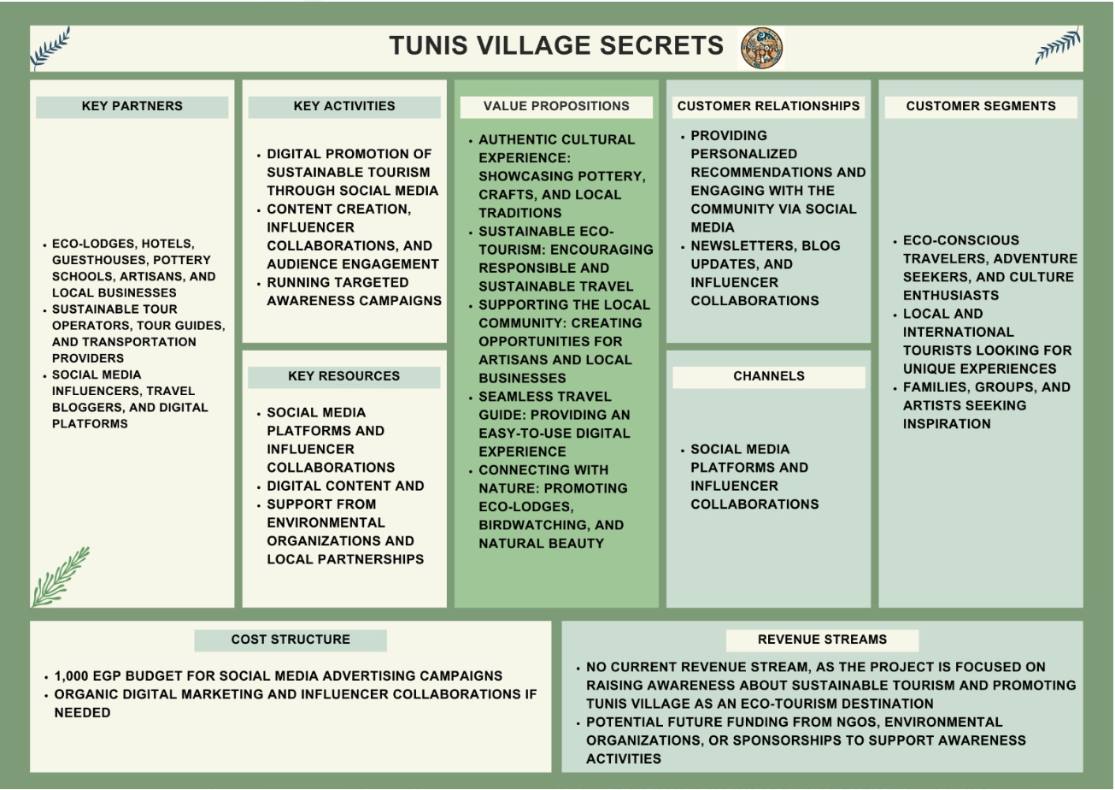

# **PART 2– Key Performance Indicators (KPIs)**

**(Collated by Noha)**

**KPIs**

|  |  |
| --- | --- |
| **Budget for paid ads** | USD 25 (EGP 1260) |
| **Targeted Page Followers** | 300 followers |
| **Organic Reach (without promotion) per post** | 40 per day |
| **Paid Reach (with promotion)** | 1000 per day |
| **Number of unique people reached per month** | 750 per month |
| **Engagement level (using engagement formula)** | 7% |

**Logic behind set KPIs**

**These have been determined as per the benchmark for new pages aimed for awareness.**

**Budget = $5 per ad x 5 ads = $25 = EGP 1260**

**Targeted Page Likes/Followers = 100–500 followers**

**The target set is therefore 300 followers/likes to the page.**

**Post Reach:**

* **Organic Reach (without promotion) =**

**As a benchmark, For 100 followers, reach should be 5–20 people per post**

* **Paid Reach (with promotion) =**

**As a benchmark, a small budget of $5 per day can get 500 –1,500 people per day.**

* **Overall Reach Benchmarks for New Pages =**

**1,000–5,000 unique people reached per month for a small business or niche page.**

**Engagement Levels (likes, comments, shares) =**

**ITEMS TO TRACK FOR POST LAUNCH ANALYSIS  :**

|  |  |  |
| --- | --- | --- |
| **Item to compare** | **Planned** | **Actual**  **(to be added after campaign)** |
| **Budget for paid ads** | $25 |  |
| **Likes/Followers** | 300 |  |
| **Organic Reach (without promotion) per post** | 40 per day |  |
| **Paid Reach (with promotion)** | 1000 per day |  |
| **Overall reach (Number of unique people reached per month)** | 750 per month |  |
| **Engagement level (using engagement formula)** | 7% |  |
| **Cost per Impression (CPM)** | $0.30 |  |
| **Cost per Engagement (CPE)** | $0.50 |  |

**ITEMS TO TRACK BESIDES KPISs, AND CONCLUSIONS TO BE DRAWN OUT OF THE FIGURES:**

**Post Clicks: The number of times people click on links, photos, or videos in your posts.**

**1. Content Performance**

* **Top-Performing Posts: To identify which types of content (e.g., images, videos, text posts, or links) get the most engagement or reach.**
* **Video Views: When sharing videos, to track views (especially 3-second and 1-minute views) to gauge interest.**

**2. Audience Growth**

* **New Followers Growth Rate: To track how quickly the audience is growing over time.**
* **Demographics and Insights: To use Facebook’s insights to understand who our audience is (age, gender, location, etc.).**

**3. Community Building**

* **Direct Messages: Monitor how many messages or inquiries we receive as an indicator of audience interest and engagement.**
* **Response Time: Track how quickly we respond to comments and messages to maintain good customer service.**

# **PART 3– Setting Project Strategy**

(Hager Sayid and Nermen Mohamed)

Project Overview & Objectives

Objective: Raise awareness about sustainable tourism and promote Tunis Village as a model for eco-tourism. The project aims to educate travelers on responsible tourism and highlight Tunis Village’s cultural and environmental value.

Strategic Action Plan

A. Community & Business Partnerships

* Collaborate with local eco-lodges and pottery schools to offer sustainable experiences.
* Work with local businesses to promote eco-friendly initiatives.
* Encourage tourists to engage with the local community through workshops and guided tours.

B. Digital Awareness & Marketing Strategy

Since the project focuses on Facebook & Instagram, the strategy includes:

1. Content Creation & Education: Posts highlighting Tunis Village’s sustainability practices.
2. Influencer & Travel Blogger Collaborations: Engaging influencers who focus on eco-tourism.
3. Engagement Campaigns: Polls, quizzes, and user-generated content to create awareness.
4. Advertising Strategy:
5. Phase 1: Awareness (March 1 - March 15) → Highlight key attractions & eco-tourism.
6. Phase 2: Engagement (March 16 - March 25) → Interactive posts, storytelling, visitor testimonials.
7. Phase 3: Action (March 26 - April 1) → Final call-to-action for visits & deeper engagement.

C. Sustainable Practices Implementation

* Encourage eco-tourists to respect local culture & environment (through content & workshops).
* Promote plastic-free travel tips for visitors to Tunis Village.
* Highlight businesses that use sustainable practices (e.g., solar energy, organic products).

 Monitoring & Evaluation Metrics

To measure the success of this strategy, we will track:

1. Social Media Metrics: Follower growth, engagement rates, shares, and interactions.
2. Visitor Interest & Community Impact: Feedback from local businesses and eco-lodges.
3. Sustainable Tourism Awareness: Increased discussions and user-generated content about Tunis Village.

Content Strategy & Calendar (Feb 19 - April 1)

Content Pillars (Themes)

1. Eco-Tourism & Sustainability: Tunis Village as a model for responsible tourism.
2. Culture & Pottery Heritage: Showcasing local artisans, pottery schools, and craftsmanship.
3. Local Experiences & Nature: Eco-lodges, outdoor activities, Lake Qaroun, and Wadi El Rayan.
4. Community & Business Spotlight: Highlighting small businesses, local food, and guest houses.
5. Engagement & Awareness: Interactive posts, polls, and user-generated content.

**Weekly Posting Plan (Content Calendar)**

|  |  |  |  |
| --- | --- | --- | --- |
| **Week** | **Instagram & Facebook (Posts & Stories)** | **Reels/Short Videos** | **Engagement Campaign** |
| **Feb 19-25** | "What is Sustainable Tourism?" + Pottery Making Insights | Behind-the-scenes of artisans at work | Quiz: "How Eco-Friendly Are You?" |
| **Feb 26-Mar 3** | "5 Must-Do Activities in Tunis Village" | Nature shots & eco-lodge tours | Poll: "Would You Try Pottery Making?" |
| **Mar 4-10** | "Meet the People of Tunis Village" | Interviews with local artisans | UGC: Share tourist photos & stories |
| **Mar 11-17** | "Eco-Lodges in Tunis Village" | Lodge walkthroughs & visitor testimonials | Challenge: "Share Your Eco-Travel Tips" |
| **Mar 18-24** | "Hiking & Nature Spots in Fayoum" | Desert & wildlife clips | Poll: "Which Tunis Experience Excites You Most?" |
| **Mar 25-Apr 1** | "Why Tunis Village is a Must-Visit Destination" | Recap of best content | Final CTA: "Visit Tunis Village This Spring!" |

**Facebook & Instagram Ad Strategy (March 1 - April 1)**

**Phase 1: Awareness (March 1 - March 15)**

* **Target: Travelers in Cairo, eco-tourists, adventure seekers.**
* **Content: Short videos (Reels), carousel posts showcasing experiences.**
* **Message: "Did you know Tunis Village is Egypt’s eco-tourism hidden gem? Discover pottery, nature, and authentic culture!"**
* **CTA: "Follow us to explore Tunis Village sustainably!"**

**Phase 2: Engagement (March 16 - March 25)**

* **Boosted Posts:**
* **“Which eco-lodge would you stay in?” (interactive poll).**
* **“Try this Tunis Village eco-travel challenge!” (carousel with travel tips).**
* **CTA: "Comment and tell us your favorite sustainable travel practice!"**

**Phase 3: Final Push (March 26 - April 1)**

* **Boost top-performing content (best-performing reels and posts).**
* **Sponsored post: "Experience sustainable tourism in Tunis Village this spring. Discover pottery, nature, and adventure!"**
* **CTA: "Visit our page to learn more!"**

1. (source: AESG - Sustainable Tourism in the Middle East, found at :   
   <https://aesg.com/wp-content/uploads/2022/07/Sustainable-tourism-in-the-Middle-East.pdf)>
2. Sally Khalil and Osama Ibrahim, Socio-Economic Development in Tunis Village: The Success Factors of a Heritage Tourism Destination found at: <https://tour.minia.edu.eg/Files/magalaa/62018.pdf>